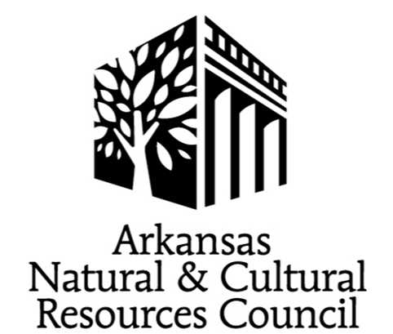

ANCRC FY 2025
Grant Application Instructions

I. Applicant Deadlines and Funding Decisions

New Online Applicants
Previous ANCRC grantees and applicants who have not applied for an ANCRC grant online should send the contact information of the Grant Coordinator who will be completing the online application/who will be the point of contact throughout the application process. Information should be sent to Debra Fithen at Debra.Fithen@arkansas.gov between the second Monday in December and the 1st Monday in February with NEW ANCRC/organization name in the subject line to receive your organization’s logon information and additional instructions.

New ANCRC Projects
For new projects, a brief summary (one paragraph) of the project is requested. With the summary, send the contact information of the Grant Coordinator who will be completing the online application/who will be the point of contact throughout the application process. Information should be sent to Debra Fithen at Debra.Fithen@arkansas.gov between the second Monday in December and the 1st Monday in February with NEW ANCRC/organization name in the subject line. If contact is not already in the online system, logon information and additional instructions will be provided.

The goal of the request is to assist applicants prior to the application deadline.

Historic Property Rehabilitation and Restoration Grants
Discussing preliminary construction plans with ANCRC and Arkansas Historic Preservation Program (AHPP) Technical Assistance Coordinator prior to application submission is recommended. Email Debra.Fithen@arkansas.gov and Mollie.Waldon@arkansas.gov before the first Monday in February.

Next Phase Applicants
If contact information has changed, email Debra.Fithen@arkansas.gov before proceeding.

If Grant Coordinator/Contact information is the same as organization’s Previous application, access to the FY 2025 application will be open on the 1st Monday in December at:
https://www.grantinterface.com/Home/Logon?urlkey=arkansasheritage.

ACCESS CODE: ANCRC

All Applicants

To be considered at the ANCRC Funding Meeting, applicants must complete the online application by 4 p.m. on the 1st Monday in March. Applications submitted after the deadline will not be considered.
Please review the Guide to Grants and the information provided at ancrc.org carefully. Email Debra Fithen, Grants Manager, at Debra.Fithen@arkansas.gov for additional information. When emailing, please include FY 2025 ANCRC/organization name in the subject line.

Power Point presentations for the Funding Meeting are due by 1st Wednesday in May.
The ANCRC Funding Meeting will be on the 2nd Wednesday in May. Applicants will receive additional information in early April.
A Mandatory Grantee Meeting must be completed no later than the 4th Wednesday in May.

II. Completing the Online Application

Questions marked with an * are required. If the question is not applicable to your project, respond NA.

Headings should be consistent throughout the application and attachments.

Round all amounts to the nearest whole dollar.

Salaries are not eligible expenses for the majority of ANCRC projects. If salaries are included in the application, provide position titles descriptions in the Additional Budget Information.

Label all attachments.

